Buccolam®
pre-filled syringes
(Buccal Midazolam, 5mg/ml)
Parent and Carer’s Information Leaflet and
Care Plan for Children at Risk of Long Seizures (Fits)

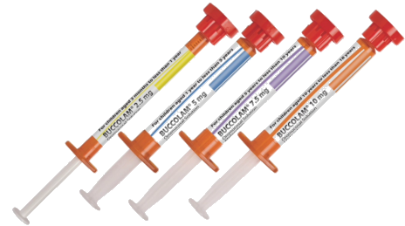

Individual Emergency Care Plan for:
Name…………………………….…DOB………………………. Weight…………

Description of typical seizure when Buccolam® ^{n}eeds to be given:

………………………………………………………………………………….................................

When should Buccolam® ^{b}e given?………………....................................................................

……………………………………………………………………………….....................................

Dose: Give: …...mg of Buccolam®. This is all of a ……………coloured Buccolam® ^{s}yringe.

Whenever you get a new prescription check that the concentration is 5mg/ml and the product is called Buccolam®. If it is not please contact us for a new care plan.

Additional Instructions?:……………………….………………………………..........................

………………………………………………………………………………….................................

………………………………………………………………………………….................................

………………………………………………………………………………….................................
Professional’s Name…………......................... Signature……..……………. Date …………

If you have any questions or concerns contact your Specialist Epilepsy Nurse.

For further advice:

Children’s Epilepsy Nurse Specialists:
DerbyRachael Wheway 01332 785103
MansfieldKirsten Johnson 01623 622515 ext 6178
Nottingham Catie Picton & Ann Brown 0115 9249924 ext 63328
Leicester 0116 2586908 end_of_the_skype_highlighting
CEWT websitewww.cewt.org.uk
Epilepsy Action Website: www.epilepsy.org.uk

EPilepsp


Many seizures will stop on their own. Some seizures need help to stop and may cause problems if they continue too long.

When do I give Buccolam®?
As well as this leaflet you should have had training on when and how to give Buccolam®. Buccolam® is the product name of a particular type of buccal Midazolam for your child. Buccolam® may be given when a child or young person with epilepsy has:
- a generalised convulsive seizure lasting more than 5 minutes. (These are seizures where the child does not respond, continues to be stiff and may jerk their arms and legs). OR
- a pattern of convulsive seizures that stop then start again straight away without recovering in between and together go on longer than 5 minutes.

How do I store Buccolam®?
Buccolam® does not need to be stored in the fridge. Further details about storage can be found in the instruction leaflet supplied with the medication. Keep it out of reach of children. Check the expiry date before using. Ensure you take Buccolam® with you if you are going out. School or other carers may also need to keep some and arrange training.

How often can I use it?
Do not use Buccolam® more than twice in any 24 hour period. Allow at least 6 hours after recovery before giving a second dose. If the first dose does not work the ambulance or hospital may give a second dose after 10 minutes.

How do I measure the correct dose?
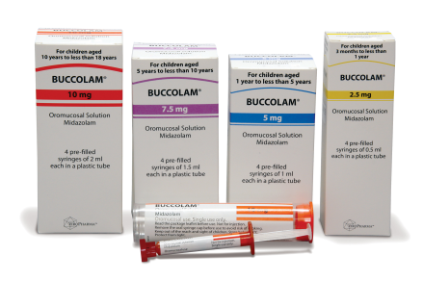
- The buccal Midazolam will come in a box containing 4 tubes each with a pre-filled syringe.
- There are different doses available so check you have the correct product and dose.
Red = 10mg; Purple = 7.5mg; Blue = 5mg; Yellow = 2.5mg.
- Remove the pre-filled syringe from the plastic tube and remove the red cap.
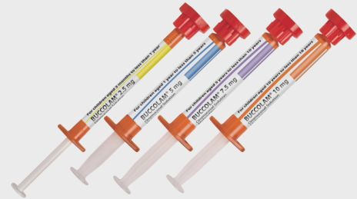

How do I give the Buccolam®?
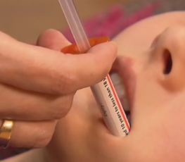
- If possible place your child on their side.
- Place the tip of the syringe between the cheek and gums on the side closest to the floor.
- Once in place, push the plunger down gently to give the medicine.
- If your child is on their back give half the dose slowly in one side and then half in the other.

Does it work straight away?
Buccolam® will take 5 to 10 minutes to work and most children will sleep for a while after the seizure has finished. They should be placed on their side during this time.

Do I need to call ‘999’?
- If you are using Buccolam® for the first time, call an ambulance straight after giving the dose. Some carers may wish to wait until the ambulance arrives on the very first occasion before giving the dose.
- If your child has had Buccolam® and is still having a seizure 10 minutes after giving the dose, OR if your child appears to have any difficulty breathing or stops breathing, call an ambulance.

Are there any side effects?
Buccal Midazolam can make your child sleepy or restless. Very rarely it may slow down breathing.

Is it safe to give if my child is taking other medicines?
Yes. But do not give it with rectal diazepam or other types of buccal Midazolam.

Disclaimer
Some children have their own individual emergency plan which may differ from this leaflet. If you have any questions, please ask your doctor or specialist nurse.

